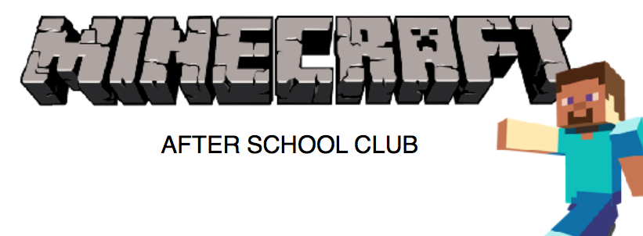
Name of Club | Minecraft Club
Provider | Mi Little Pad Ltd
Contact Name | Catherine Cains / Codie Stephens
Telephone | 01633 383211
Email | cath@milittlepad.com / codie@milittlepad.com
School Name
First Half of Term Dates
Half Term Dates
Second Half of Term Dates
If your club is booked 1 term at a time, please leave Club End date 1 and start date 2 blank.
Club Start Date 1st Half of term
Club End Date 1st Half of Term
Day of Club
Time of Club
Any Events/Trips/Inset Days/Parents Evenings that will affect the club?

*If you have 2 clubs, please write down dates/days/times for both clubs.*
Type of Devices that will be used for the club? E.g. iPads, Laptops
No. of Devices with Minecraft available?
Can children bring their own devices to use in the club?
Year Group the club is open to?

